How do organisms use energy?

1a. Why does your body need energy?

1b. Why does an adult who is not growing need to eat food?

Your body’s cells need a constant supply of energy for movement, synthesizing molecules, and other cellular processes. To supply energy for these processes, your body uses the following steps.
- First, your food is digested to small organic molecules like glucose which travel in the blood to all the cells in your body.
- Next, your cells use glucose and other small organic molecules as input for a process that makes ATP.
- Then, your cells use ATP to provide the energy for cellular processes.

Making ATP
In cellular respiration, glucose or another small organic molecule is one input for reactions that provide the energy to make ATP from ADP plus a phosphate (P).

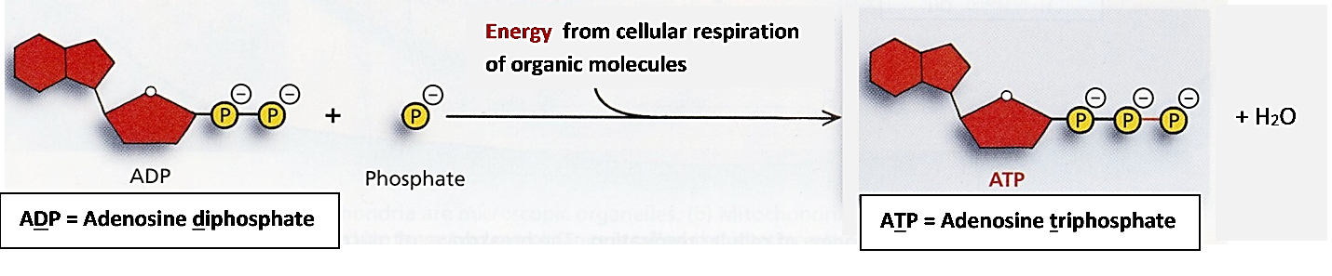

2. Give one reason why energy input is needed to combine ADP and P to make ATP. (Hint: Examine the figure above.)

Using ATP
The reaction of ATP and water to produce ADP + P is called the hydrolysis of ATP. The hydrolysis of ATP provides the energy for many cellular processes, e.g., synthesizing molecules and muscle contraction.
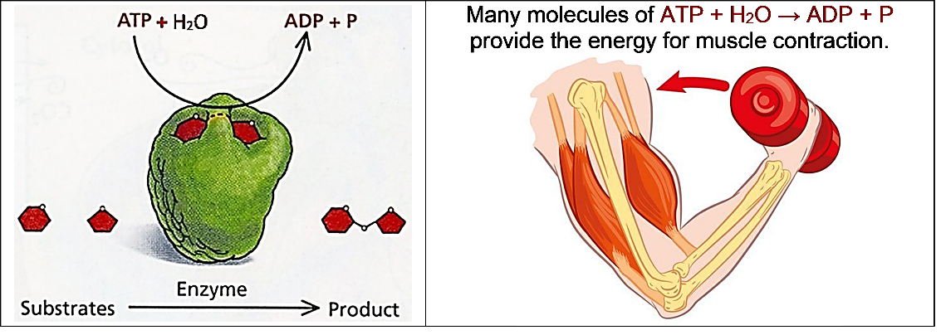
3a. Inside each cell, there is a constant cycle of making ATP and hydrolysis of ATP. Add to this diagram to show:  - the source of energy to make ATP;  - how the hydrolysis of ATP is useful. | 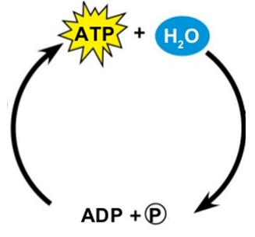
3b. Why does a cell need to constantly break down ATP to ADP + P and then remake ATP?

Cellular respiration makes ATP.

These chemical equations summarize cellular respiration. The first chemical equation summarizes a series of reactions that release energy. Energy input is needed to make ATP. The curved arrows represent the transfer of energy from the reactions that release energy to | 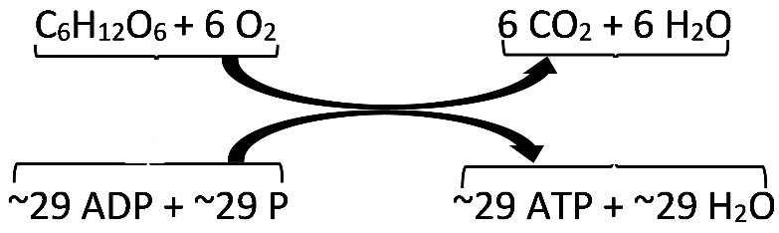
the reactions that make ATP. Cellular respiration of a single molecule of glucose provides enough energy to make about 29 molecules of ATP.

4a. Circle the chemical reaction that requires energy input.

4b. Write the names of each of the molecules in the top chemical equation.

5. Why do we need to breathe all day and all night?

6. How do the cells in your body get glucose for cellular respiration?

7a. If you search for "cellular respiration equation" on the web, some of the most popular sites give the following chemical equation for cellular respiration of glucose.
C₆H₁₂O₆ + 6 O₂ 6 CO₂ + 6 H₂O + ATP
What is wrong with this chemical equation? (Hint: Think about where the atoms in an ATP molecule come from.)

7b. Write a corrected version of this chemical equation that gives a more accurate summary of cellular respiration.

Using ATP to Provide Energy for Biological Processes
The hydrolysis of ATP provides the energy for many biological processes. For example, the hydrolysis of a molecule of ATP provides the energy for a muscle protein to change shape and contract the muscle a tiny bit. Many many repeats of these reactions result in muscle contraction.
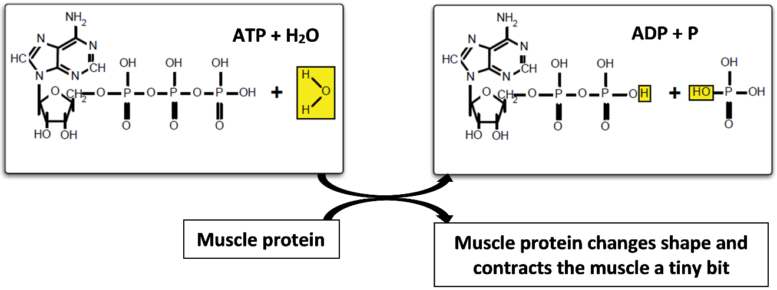
8a. Explain why the top reaction is called the hydrolysis of ATP. (Hint: Hydro means water and olysis means breaking down or separating.)

8b. What do the curved arrows represent?

9a. The reaction, ATP + H₂O → ADP + P occurs
in all the cells in your body___ only in muscle cells ___

9b. Explain the reasoning that supports your answer.

Two important general principles about energy are:
- Energy can not be created or destroyed by biological processes.
- Whenever energy is transformed from one type to another, some of the energy is transformed to thermal energy. (For example, only about 20-25% of the energy released by the hydrolysis of ATP is transformed to the kinetic energy of muscle contraction and the rest is transformed to thermal energy.)

10a. During cellular respiration, most of the ATP production takes place in organelles called mitochondria. Some textbooks claim that "Mitochondria make the energy needed for biological processes." Explain what is wrong with this sentence.

10b. Revise the sentence to be more accurate.

11. Explain why your body gets warmer when you are physically active.

By Dr. Ingrid Waldron, Univ Pennsylvania, © 2023. This Student Handout (including a Google Docs version) and Teacher Notes (with instructional suggestions and background information) are available at https://serendipstudio.org/exchange/bioactivities/energy.

